

PENETRATION TESTING RESEARCH REPORT
Shark Jack Cable - Network Recon and Aggressive Scanning

9 MAY 2026
AUTHOR: SZYMON STEFAŃSKI
CLASSIFICATION: EDUCATIONAL RESEARCH FOR KN PING
ENVIROMENT: LOCAL LAB NETWORK
VERSION: 2.0

Statement Of Confidentiality
The contents of this document have been developed by Szymon Stefański, during research work and testing of one of the tools produced by the Hak5 company called “Shark Jack Cable”. Information included in this report is considered to be used ONLY for educational purposes and performance of its intended use.
All the contents of this document that will be used outside of its legal purposes and educational functions will be considered an act of illegal actions, that the author does not take responsibility for.

Contents
Statement Of Confidentiality 1
Executive Summary 3
Research Objectives 3
Scope 3
Assessment Overview 4
Network Reconnaissance and Scanning Penetration Test assessment Summary 4
Technical Challenges 4
Connectivity 4
Infrastructure Decay 5
Summary Of Findings 5
Attack Architecture Overview 6
File Structure 6
Attack Flow Diagram 7
Testing Summary 7
Remediation Summary 7
Appendices 8
Appendix A: Sample Loot Output 8
Appendix B: Repository Fix (distfeeds.conf) 9
References 9

Executive Summary
This report documents the research, development, and testing of an automated network reconnaissance tool built on the Hak5 Shark Jack Cable (SJC)—a compact, Linux-based penetration testing device disguised as an Ethernet adapter cable. The device was configured to perform automated Host Discovery, Port Scanning, Service Enumeration, OS Fingerprinting, and Passive Traffic Analysis upon physical connection to a target network.
Testing was conducted in a controlled Home Lab environment consisting of a consumer-grade router and multiple endpoint devices. The results demonstrated that the Shark Jack Cable is capable of extracting significant network intelligence within minutes of being plugged into a standard RJ45 Ethernet port, while also revealing the effectiveness of Host-Based Intrusion Prevention Systems (HIPS) such as ESET in detecting and partially mitigating reconnaissance activity.

Research Objectives
The primary objectives of this research were to understand the mechanics behind Hak5 Shark Jack Cable as a Hotplug device capable of disguising itself as Ethernet adapter ( network device ) to perform various activities via Bash script payload or discovering limitations of physical-access penetration testing device. Other objectives include the NETMODE mechanism capable of changing the way SJC is seen on the network, evaluation of ESET network security measures and document infrastructure decay challenges associated with maintaining legacy IoT security tools.

Scope
Attack Device | Hak5 Shark Jack ( Cable version )
Internal OS | OpenWrt 18.06-SNAPSHOT ( Linux )
NETMODE | DHCP_SERVER, DHCP_CLIENT
Target Device(s) | Home router, Local network, endpoint devices
Security Measurements | Built-in Firewall, ESET Security Ultimate
Network | Local ( access to Internet )
Lab Type | Local home lab
Additional Tools ( Pre-installed ) | Nmap (v7.70), Tcpdump (v4.9.2), Bash, OpenSSH

Assessment Overview
During the initial penetration test against the local network via Router, there were no issues with the script or the process as a whole. However, devices with installed ESET Security antivirus managed to block the port scanning resulting in ‘filtered’ mark upon scanning.
There were also technical failures during connectivity testing of Shark Jack Cable and infrastructure set up and updates. Not all of them were resolved, but in fact I documented them as well to further explain my decisions during writing of the script.

Network Reconnaissance and Scanning Penetration Test assessment Summary
Target Router upon connecting SJC via RJ45 end at first treated it as DHCP server, creating a conflict, as both of those devices were trying to assign IP addresses, creating a Race Condition situation. However after NETMODE changed to client ( using the script ) SJC was identified as a guest on the Network, allowing it to blend in, get its own IP address and perform stealth scanning.

Technical Challenges

Connectivity
Before payload development, significant effort was required to establish a stable management connection to the Shark Jack Cable.
The SJC is designed to present two USB interfaces simultaneously:
- Interface 0: Serial Console (via Silicon Labs CP2102 UART Bridge)
- Interface 1: Network Adapter ( via RNDIS — Remote Network Driver Interface Specification ) ( SSH Protocol )
Windows 10/11 failed to recognize the RNDIS ( Network ) interface. The host OS associated the entire device with the CP2102 Serial driver, preventing the Network Adapter from initializing, therefore SSH connection was impossible via USB-C cable.
Troubleshooting steps included:
- Manual driver selection ( forcing Microsoft "Remote NDIS Compatible Device" ).
- Legacy hardware installation via Device Manager.
- Custom .inf file creation to override the Hardware ID ( VID_10C4&PID_EA60 ).
- Registry and Driver Store cleanup ( pnputil /delete-driver ).
The root cause was identified as a USB-C Data Role Negotiation conflict, where the host's USB-C controller locked the port into "Serial Mode" due to the CP2102's Hardware ID, preventing the secondary RNDIS interface from initializing.
Successful way of SSH connection is to connect to the Router, set DHCP_CLIENT as NETMODE to assign IP address and Internet connection to Shark Jack, checking its new IP via ‘ifconfig’ command on serial console and performing SSH connection to that IP, as follows in Hak5 documentation.

Infrastructure Decay
The original payload design included an Active Man-in-the-Middle (MitM) phase using arpspoof (from the dsniff package) to intercept HTTP traffic between a target and the gateway. However this phase was abandoned due to multiple issues of Shark Jack’s software and hardware, including:
- Outdated repository links for opkg manager : SJC was trying to pull packages from archives that were no longer present resulting in failed updates.
- Certificate / Signature Expiration: Even after manually redirecting distfeeds.conf to the OpenWrt 18.06.9 Archive ( http://archive.openwrt.org/releases/18.06.9/packages/mipsel_24kc/... ), the opkg tool's internal wget binary failed to download .ipk files due to outdated SSL/TLS root certificates and GPG signature mismatches.
- Binary Absence: The dsniff package (containing arpspoof) was confirmed to be absent from the OpenWrt 18.06.9 mipsel_24kc package index entirely, suggesting it was either never compiled for this architecture or was removed due to space constraints.
- Nmap Scripting Engine (NSE) Unavailability: The pre-installed Nmap binary lacked the /usr/share/nmap/scripts/ directory. The --script=vuln flag was non-functional because the Lua-based NSE library was excluded from the firmware to conserve flash memory.

Summary Of Findings
- A physical device the size of an Ethernet cable can perform comprehensive network reconnaissance within minutes of being connected to a single LAN port. No credentials, no Wi-Fi passwords, and no user interaction are required.
- ESET successfully blocked TCP port scanning, but could not prevent ARP-based host discovery or MDNS service enumeration. A determined attacker can still map the network topology and identify vulnerable (unprotected) devices. A "Race Condition Window" of approximately 10-15 seconds exists between adding a folder exclusion and Defender's post-process behavioral scan, during which a known tool can execute successfully.
- Devices without endpoint security (Smart TVs, streaming devices, printers) were completely transparent to the Shark Jack, revealing open ports, running services, and firmware versions.
- The Shark Jack's reliance on deprecated OpenWrt repositories rendered its advanced attack capabilities (arpspoof, NSE scripts) inoperable. This highlights the risk of depending on vendor-maintained toolchains for long-term security research.
- The absence of any plaintext HTTP traffic confirms that modern encryption standards (HSTS, TLS 1.3) have made passive "Wire Sniffing" largely ineffective for credential theft on modern networks.

Attack Architecture Overview
The attack takes advantage of Shark Jack’s NETMODE setting, allowing it to change its behavior based on needs. In this case, it was set as CLIENT for stealth, Internet connection and IP address. The payload itself was written in Bash, with no additional tools installed ( due to failures ). The script used tools like nmap and tcpdump to perform scanning and save all gathered information on the SJC loot folder.

File Structure
/root/loot/
- scan_results/
  - SUMMARY.txt
  - network_info.txt
  - alive_hosts.txt
  - gateway_scan.txt
  - arp_traffic.txt
  - deep_scan.txt
  - http_traffic.txt
  - mdns_traffic.txt
- audit_results/
  - detailed_audit_*.txt
/root/payload/
- payload.sh
As above, the whole loot folder separates into two subfolders, containing a large number of data gathered through scans. In the root directory is also placed a payload folder containing the script.

Attack Flow Diagram
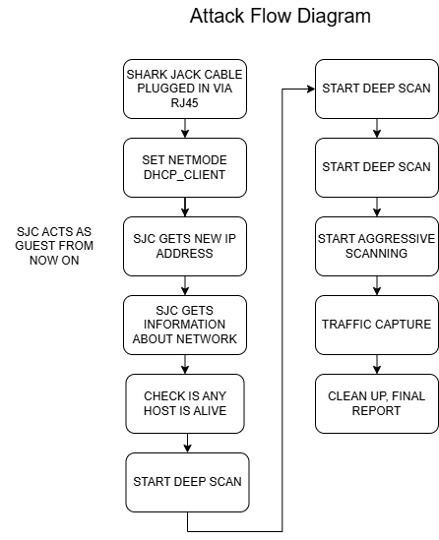

Testing Summary
Shark Jack successfully scanned the Network via Router, gathering high value information about various traffic, network, endpoint devices, ports and services. Despite technical issues this version of payload managed to work and perform without being directly detected ( only the tcp port scanning alert was received from ESET ). During payload execution SJC safely created and copied data to its loot storage. At the end it cleaned up the processes and was ready to be plugged out. The whole process took approximately 8 minutes.

Remediation Summary
Defense | Effectiveness | Method
Implement 802.1X | High | Port-Based Access Contro
Enable DHCP Snooping | Med | DHCP settings
Deploy ARP Inspection | High | DAI ( Dynamic Arp Inspection )
Monitoring Nmap Signatures | Med | IDS/IPS systems
Segment IoT Devices | High | VLAN with restricted access to the main network

Appendices

Appendix A: Sample Loot Output
Note that those are only fragments of some files.
arp_traffic.txt
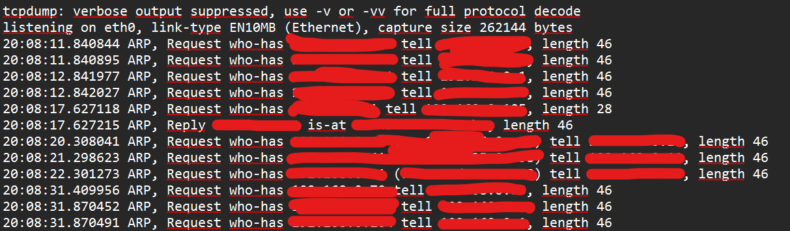
deep_scan.txt
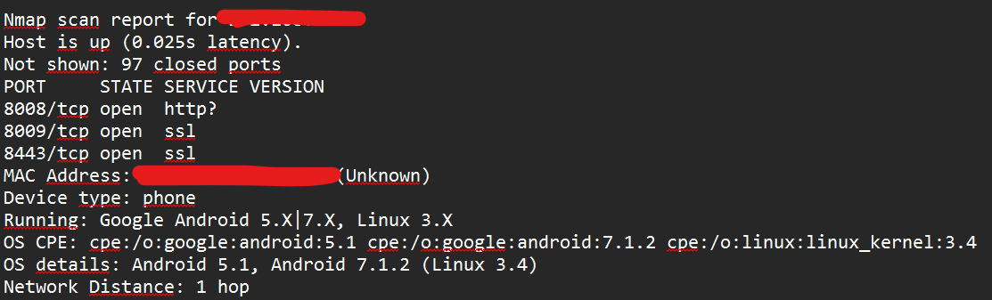
SUMMARY.txt
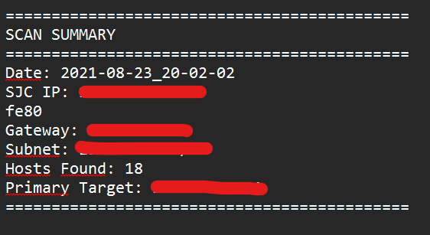
alive_hosts.txt
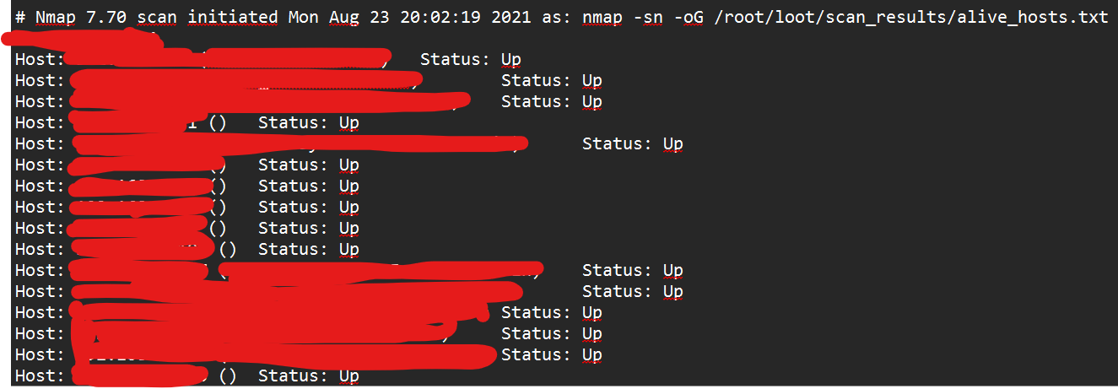

Appendix B: Repository Fix (distfeeds.conf)
src/gz openwrt_base http://archive.openwrt.org/releases/18.06.9/packages/mipsel_24kc/base
src/gz openwrt_packages http://archive.openwrt.org/releases/18.06.9/packages/mipsel_24kc/packages
src/gz openwrt_routing http://archive.openwrt.org/releases/18.06.9/packages/mipsel_24kc/routing

References
- Hak5 – Shark Jack Documentation
https://docs.hak5.org/shark-jack/shark-jack-by-hak5/
- OpenWrt Project Documentation:
https://openwrt.org/docs/start
- Microsoft RNDIS (Remote NDIS) Specification:
https://learn.microsoft.com/en-us/windows-hardware/drivers/network/overview-of-remote-ndis--rndis-
- RFC 2131: Dynamic Host Configuration Protocol (DHCP)
https://datatracker.ietf.org/doc/html/rfc2131
- RFC 826: An Ethernet Address Resolution Protocol (ARP):
https://datatracker.ietf.org/doc/html/rfc826
- OpenWrt Package Archives:
https://archive.openwrt.org/
- Silicon Labs CP210x USB to UART Bridge VCP Drivers:
https://www.silabs.com/developers/usb-to-uart-bridge-vcp-drivers
- MITRE ATT&CK Framework - Network Service Scanning (T1046):
https://attack.mitre.org/techniques/T1046/

